Swimming championships
Swim Manager instructions

2022-2023



Swim manager instructions
With over 4600 swimmers entering the qualifiers there is a huge amount of competitor data to process. We ask schools to support what is a very complex event to organise by processing their own competitor details on Swim Manager. The Meet Entries website streamlines the meet entry process for schools and host schools. It also ensures that all your competitor’s names are spelt correctly, and they are entered into the correct races. If they qualify for the finals, their names will appear on the big screens at the Aquatic Centre so it’s best if you enter them to avoid any mistakes.

Step 1: complete IAPS swimming competitor details Excel document
- Add all swimmers’ details to the relevant cells.
- The Registration number; does not need to be completed.
- For relays complete the fields as below.
First Name – Team
Last Name – A
Sex – Male or Female
Entry Time - NT
Entry Time Course - SC

- Save the file on your laptop/ PC. You will need to upload this file to the Meet Entries website at a later stage.

Step 1: visit meet entries website
- Visit the meet entries website here.

Step 2: register your school

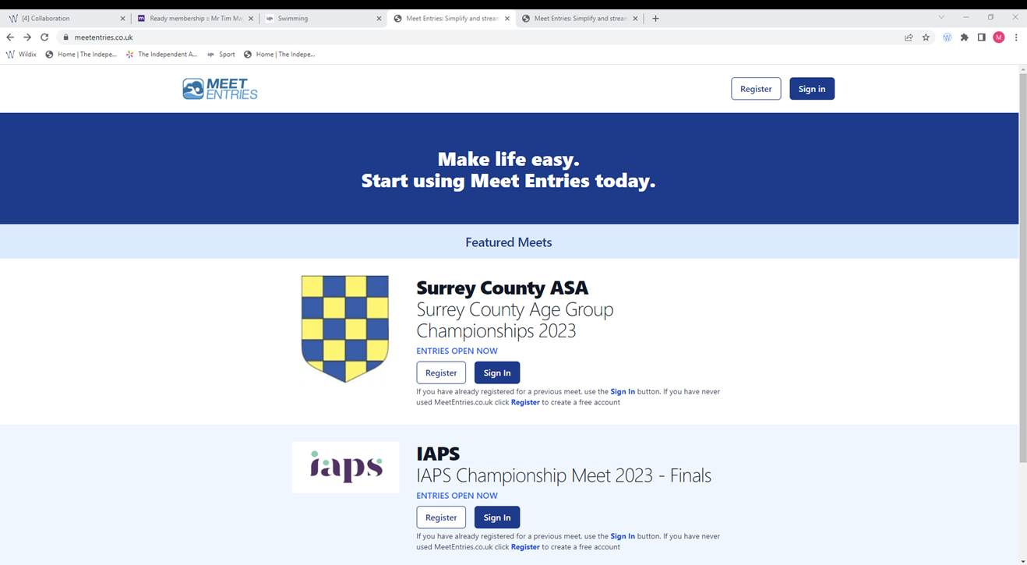
- Select the Register button in the top right corner of the web page. Please make sure the ‘Register’ button you select is the one in the top right of the screen and NOT the button under the IAPS Championships Meet 2023 – Finals.

- Find your school name within the Organisation drop-down.
- Complete the Name, email and password boxes and click register.

Step 3: new club entry
- Scroll down to find the IAPS qualifying round that you are attending.
- Select the New Club Entry button underneath that IAPS qualifying round.

Step 4: contact details
- Select your school from the dropdown box underneath the organisation heading.
- Complete the Contact Details section and enter TBC into the Bank Details section.

Step 5: uploading Excel document software.
- In the Meet Entry section, select Excel/ CSV Entry file from the drop-down underneath Meet Management Software heading.
- Select the upload a file option.
- Find and upload the ‘IAPS swimming competitor details’ Excel document that you have saved on your PC/laptop.

Step 6: Save
- Click Save

If you need any support using Swim Manager, please contact IAPS Sport or call 01926 887833.

Website https://iaps.uk/sport.html
Twitter @iapsuksport
Instagram @iapsuksport

Emily Connell
Sport Events Manager & Safeguarding Officer
Mike Kershaw
Sport Events Coordinator & Deputy Safeguarding Officer
James Taylor
Events Administrator
sport@iaps.uk



