sport

**U11 Boys Football Qualifier**

**Saturday 21st September 2024**

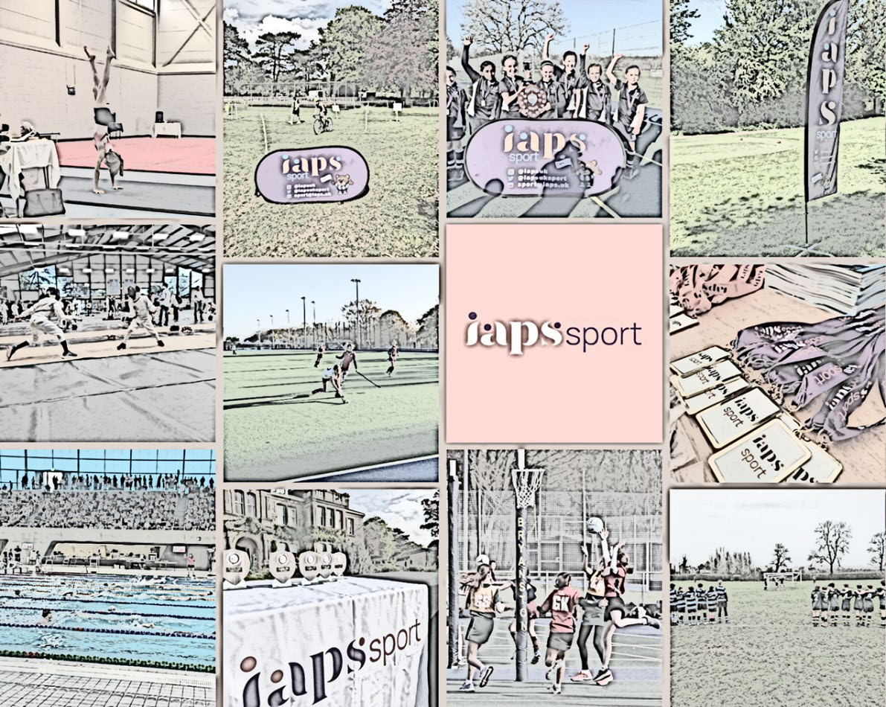



WELCOME FROM SCHOOL

Good afternoon and a warm welcome to Danes Hill School. It is a pleasure to have players, staff, parents, and spectators with us today for the IAPS Regional Qualifiers. We hope the weather remains favourable and that everyone has an enjoyable and memorable experience.

We trust that all participating schools will relish not only the tournament itself but also our beautiful grounds and the outstanding facilities here at Danes Hill. Our grounds team consistently maintains our football pitches to the highest standards, and combined with the calibre of the players, we anticipate a day of exciting football.

This marks the fifth year we are hosting the qualifying round, and each year we are deeply impressed by the enthusiasm and support shown for the players. We kindly ask that both players and spectators approach the day in the right spirit. Sport provides a wonderful opportunity to learn valuable life lessons, including the importance of emotional control and conducting oneself with grace, even in challenging situations. I hope we can all embrace today’s competition, appreciating the challenges and atmosphere of tournament football while maintaining respect and dignity, regardless of the outcome.

Best of luck to all participants. Play hard, enjoy the competition, and make the most of this wonderful morning.

Chris Shaw

Director of Sport

**WELCOME FROM IAPS**

First and foremost, sport is about participation and enjoyment. Sport is an incredibly important part of the personal development of children. Thanks to our eager and enthusiastic membership, over 22,000 children take part in the IAPS Sport programme every year. With 22 sports to choose from and over 170 events organised annually, there are plenty of opportunities for our member schools to get involved in.

Whether this is your first time at an IAPS event, or you

have been entering them for many years, we hope you enjoy the competition and good luck!

**CODE OF CONDUCT FOR SPECTATORS**

Where permitted, we are delighted to welcome spectators to attend IAPS events.

As a **spectator/parent** at an IAPS sports event, you have a responsibility to:

As a **spectator/parent** you have a responsibility to:

1. Be a positive role model and lead by example. Children are involved in sport for their enjoyment and without undue spectator pressure.
2. Encourage children to play by the rules and respect the officials.
3. Always respect the officials and their decisions. Video evidence will not be accepted in any cases to dispute decisions.
4. Always respect the coaches and their decisions. They give their time, energy and experience to coach the children.
5. Refrain from any form of bad language or poor behaviour towards players, officials and fellow spectators.
6. Be friendly and respectful to the opposition.
7. Teach children that effort and teamwork are as important as victory so that the result of each game is accepted without undue disappointment.
8. Turn defeat into victory by helping children work towards skill improvement and a positive sporting attitude.
9. Be aware that IAPS events have comprehensive safeguarding policies and procedures, available on our website: <https://iaps.uk/sport/safeguarding.html>
10. Try to relax and enjoy the event!

IAPS wants all competitions to run without any negative incidents. Excitement and emotions can run high at events, not least amongst the supporters. Unpleasant and inappropriate behaviour is very rarely seen but you should be aware that **IAPS retains the right to ask you to leave the event if you fail to comply with the code of conduct.**

**SAFEGUARDING**

IAPS believes that the welfare and wellbeing of all children (young people under the age of 18) and adults at risk attending an IAPS event is of the highest concern. All such persons have the right to safety and protection and any suspicions, concerns or allegations of harm will be taken seriously and will be dealt with swiftly and appropriately.

IAPS expects all adults who are engaged with the delivery of sports events to fully comply with safeguarding procedures as laid out in the IAPS Safeguarding Policy and Procedures, and the KCSiE document (these are available on our website: sport.iaps.uk/safeguarding).

IAPS expects all coaches present to be DBS checked and have received relevant safeguarding training at their school/club.

IAPS expects that all adults attending events have read the IAPS code of conduct, photo policy and anti bullying policy. These are available to read and download from our website here: sport.iaps.uk/safeguarding.

If you have any safeguarding concerns today, please don’t hesitate to speak to Emily Nunan, Mike Kershaw or a member of the organising team.

**IAPS designated safeguarding officer**

Emily Nunan

Head of Sport and Pupil Experience

[egn@iaps.uk](mailto:egn@iaps.uk)

**IAPS deputy safeguarding officer**

Mike Kershaw

Sport and Pupil Experience Manager

[mjk@iaps.uk](mailto:mjk@iaps.uk)

**EVENT INFORMATION**

Parking

Mini buses are to arrive via our back entrance, off Wren’s Hill road. Coaches, players and parents to arrive via our main entrance (KT22 0JG). Parents to car share where possible as there is limited parking in the surrounding area.

Late arrivals

If you are late for your fixture the opposition team will be awarded a 2-0 win and 3 points.

Tournament schedule

8.15am Arrival

8.45am Coaches and referees meeting

9am Group stages start

11am Knockout stages start

12.30am Presentation

Referees

We have sourced referees for the competition.

Qualification process

1st and 2nd from each group will qualify for the CUP competition, 3rd and 4th from each group will qualify for the PLATE competition.

The top 3 teams in the CUP competition will qualify for National Finals Day at Millfield Prep School on Sunday 24th November.

First aid

Please can schools bring their own First Aid bags. We are hoping to have Medical Dispatch on site for the tournament, however if they do not arrive staff will be responsible for injuries their players. Danes Hill staff will be available to assist.

Changing facilities

Please come changed and ready to play. We limited changing facilities available.

Refreshments

We will provide a snack box for each team and refreshments for staff and parents. It will be worth asking your pupils to bring some food with them.

**EVENT INFORMATION**

Merchandise

IAPS are delighted to have Team Elite as our official merchandisers, to sell branded products both online and at events throughout the year. All commission made from merchandise is directly put back into running the sports programme. Merchandise can be bought online or at several IAPS sport events.

Results

Results for team events will be published live using SOCS. Results for individual sports event will not be available live but will be published on our website as soon as possible after the event.

Please note all results are now published in the member area of our website which is only accessible to school staff. Parents should request any information from the school.

Photography advice

There is no professional photography at IAPS Sports events, however parents and spectators can take their own pictures. There is no law against taking photos at public events for personal use, including pictures of other people’s children ([Ask the Police, 2018](https://www.askthe.police.uk/content/Q717.htm)). IAPS asks parents and spectator to be cautious when sharing any images on social media.

The NSPCC have useful advice on sharing images here: [**https://learning.nspcc.org.uk/research-resources/briefings/photography-**](https://learning.nspcc.org.uk/research-resources/briefings/photography-sharing-%20images-guidance/)[**sharing- images-guidance/**](https://learning.nspcc.org.uk/research-resources/briefings/photography-sharing-%20images-guidance/)

**LIST OF SCHOOLS/POOLS**

|  |  |  |  |
| --- | --- | --- | --- |
| **Group A** | **Group B** | **Group C** | **Group D** |
| **A1**  **Danes Hill School** | **B1**  **Lambrook School** | **C1**  **Hoe Bridge School** | **D1**  **Aldro School** |
| **A2**  **Parkside** | **B2**  **Westbourne House School** | **C2**  **Downsend School** | **D2**  **Feltonfleet School** |
| **A3**  **Moulsford Prep School** | **B3**  **St George’s School** | **C3**  **Wellington College Prep** | **D3**  **Halstead St Andrew’s School** |
| **A4**  **Abingdon Prep School** | **B4**  **Cranleigh Prep School** | **C4**  **Aberdour School** | **D4**  **St Christopher’s Prep School** |

**POOL MATCHES**

|  |  |  |  |  |
| --- | --- | --- | --- | --- |
| **Time** | **Pitch 1** | **Pitch 2** | **Pitch 3** | **Pitch 4** |
| **9am** | **A1 v A2** | **A3 v A4** | **B1 v B2** | **B3 v B4** |
| **9.15am** | **C1 v C2** | **C3 v C4** | **D1 v D2** | **D3 v D4** |
| **9.30am** | **A1 v A3** | **A2 v A4** | **B1 v B3** | **B2 v B4** |
| **9.45am** | **C1 v C3** | **C2 v C4** | **D1 v D3** | **D2 v D4** |
| **10am** | **A1 v A4** | **A2 v A3** | **B1 v B4** | **B2 v B3** |
| **10.15am** | **C1 v C4** | **C2 v C3** | **D1 v D4** | **D2 v D3** |

**Plate Competition**

|  |  |  |  |  |
| --- | --- | --- | --- | --- |
| **Time** | **QF 1** | **QF 2** | **QF 3** | **QF 4** |
|  | **Pitch 1** | **Pitch 2** | **Pitch 3** | **Pitch 4** |
| **11.15am** | **3rd place Group 1**  **V**  **4th place Group 3** | **4th place Group 2**  **V**  **3rd place Group 4** | **3rd place**  **Group 2**  **V**  **4th place Group 4** | **4th place Group 1**  **V**  **3rd place group 3** |
|  | | | | |
|  | **SF 1** | | **SF 2** | |
| **11.45am** | **Pitch 3** | | **Pitch 4** | |
| **Winner of QF 1**  **V**  **Winner of QF 3** | | **Winner of QF 2**  **V**  **Winner of QF 4** | |
|  | | | | |
| **12 noon** | **Plate Final** | | **3rd Place Play-off** | |
|  | **Pitch 3** | | **Pitch 4** | |
| **Winner of SF 1**  **V**  **Winner of SF 2** | | **2nd Place in SF 1**  **V**  **2nd Place in SF 2** | |

**Cup Competition**

|  |  |  |  |  |
| --- | --- | --- | --- | --- |
| **Time** | **QF 1** | **QF 2** | **QF 3** | **QF 4** |
|  | **Pitch 1** | **Pitch 2** | **Pitch 3** | **Pitch 4** |
| **11am** | **1st place Group 1**  **V**  **2nd place Group 3** | **2nd place Group 2**  **V**  **1st place Group 4** | **1st place**  **Group 2**  **V**  **2nd place Group 4** | **2nd place Group 1**  **V**  **1st place group 3** |
|  | | | | |
|  | **SF 1** | | **SF 2** | |
| **11.30am** | **Pitch 1** | | **Pitch 2** | |
| **Winner of QF 1**  **V**  **Winner of QF 3** | | **Winner of QF 2**  **V**  **Winner of QF 4** | |
|  | | | | |
| **12 noon** | **Plate Final** | | **3rd Place Play-off** | |
|  | **Pitch 1** | | **Pitch 2** | |
| **Winner of SF 1**  **V**  **Winner of SF 2** | | **2nd Place in SF 1**  **V**  **2nd Place in SF 2** | |

**PITCH LAYOUT**

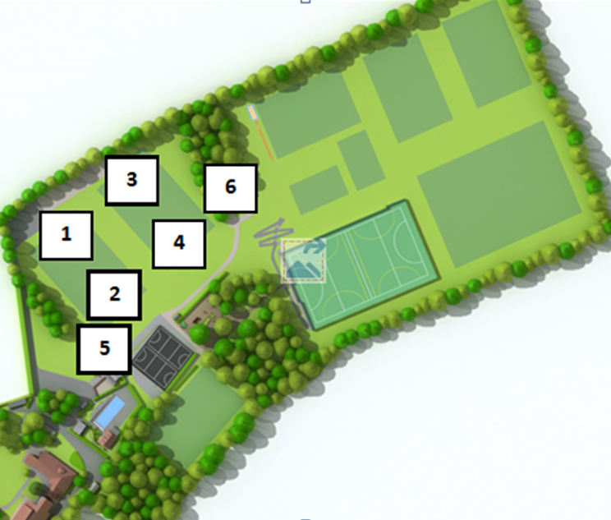

1. **Pitch 1**
2. **Pitch 2**
3. **Pitch 3**
4. **Pitch 4**
5. **Cricket Pavilion – Parent refreshments**
6. **Players Toilets**

**RULES AND REGULATIONS**

* **Maximum squad size of 10**
* **Matches will be 7v7**
* **A size 4 football will be used**
* **Matches will be 10 minutes one way**
* **Rolling substitutions once the ball is off the pitch and the referee is happy for a substitution to occur.**
* **3 points for a win, 1 point for a draw and 0 points for a loss**
* **If teams are level on points:**
* **Head to head result**
* **Goals scored**
* **Goal difference**
* **Penalty shootout – 3 each**
* **During the knockout stages if the match is tied after 10 minutes, we will go straight to penalties, 3 each then sudden death.**

sport

**Website** - <https://iaps.uk/sport.html>

**Twitter** - @iapsuksport

**Instagram** - @iapsuksport

Email – sport@iaps.uk

Emily Nunan

**Head of Sport and Pupil Experience**

[egn@iaps.uk](mailto:egn@iaps.uk)

01926 461501 (Direct Line)

07469 853452 (Mobile)

Mike Kershaw

**Sport and Pupil Experience Manager**

[mjk@iaps.uk](mailto:mjk@iaps.uk)

01926 461513 (Direct Line)

07884 453783 (Mobile)

Rachel Eatough

**Sport and Pupil Experience Administrator**

rae@iaps.uk