IAPS U11 BOYS RUGBY FESTIVAL 2024

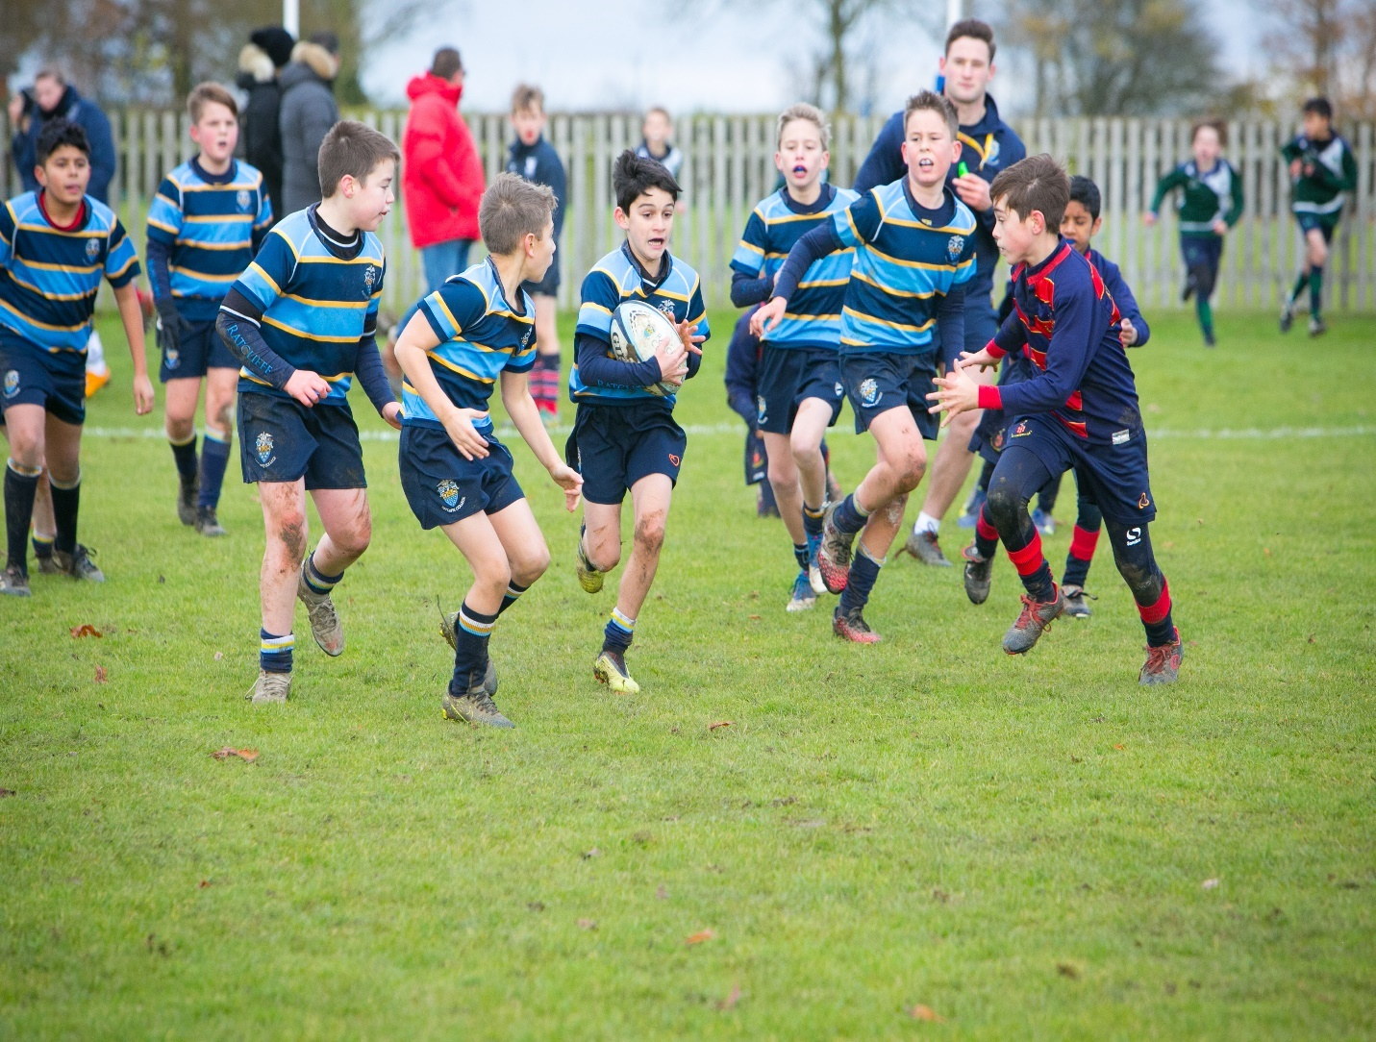

WELCOME FROM RATCLIFFE COLLEGE

Rugby has a rich heritage at Ratcliffe College and therefore we are very excited to be hosting the IAPS Midlands U11 Rugby Festival this year. The Ratcliffe Rugby journey starts in Year 3 where the children learn the Fundamental skills of the game before moving through the Prep School where they get to experience the excitement of fixtures and develop their skills and strategic understanding of the game further before moving into the Senior School. All our pupils and students receive specialist coaching which is both age and ability appropriate to ensure that every child/student benefits from their Rugby experience and develops a lifelong love of the game. Old Ratcliffian Lewis Deacon went on to represent England after his time at Ratcliffe, an achievement that inspires all that follow him through a Ratcliffe Rugby life.

WELCOME FROM IAPS

IAPS passionately believes in the importance of sport as part of an all-round education for its pupils. First and foremost, sport is about participation and enjoyment. It should be seen as an important part, but only a part, of the personal development of each child. IAPS hosts a wide range of sporting events each year, which are hugely popular with pupils.
A full list of our events is available to see on our website here: sport.iaps.uk.
Whether this is your first time at an IAPS event, or you have been entering them for many years, we hope your school enjoys the competition. IAPS passionately believes in the importance of sport as part of an all-round education for children. First and foremost, sport is about participation and enjoyment – good luck!

PHOTOGRAPHY
There will be no professional photography at any IAPS events, however, parents and spectators can take their own pictures. There is no law against taking photos at public events for personal use, including pictures of other people’s children (Ask the Police, 2018). IAPS asks parents and spectators to be cautious when sharing any images on social media. The NSPCC have useful advice on sharing images.

IAPS U11 RUGBY FESTIVAL

It is essential that all spectators, staff and students recognise that this is a Festival not a Tournament and as such no official scores will be kept as per RFU guidelines for U11 competition/fixtures. The focus of the day is that all the players enjoy their experience of the great game of Rugby in a safe, secure and supportive environment.

CODE OF CONDUCT FOR SPECTATORS
Your school is a member of IAPS, the Independent Association of Prep Schools. IAPS is a school’s association with 670+ member schools, both in the UK and internationally. IAPS was founded in 1893 and for over one hundred year’s we have been committed to supporting Headteachers in their roles as leaders of the top Prep and Independent Junior Schools in the country. Membership of IAPS says a great deal about the quality of the school you send your child to for their education.
We provide services to our members offering support and guidance to Headteachers and professional training for staff. We also provide opportunities for children to take part in sport and art competitions. We are not a private company solely engaged in running sports competitions
The annual sports programme offers a range of team and individual events for children who attend IAPS schools. The children are able to compete in a fun, safe and competitive environment. All organisers and qualified officials are passionate volunteers, who help us to deliver the events in line with National Governing Body rules and regulations.
Where permitted, we are delighted to welcome spectators to attend IAPS events to support the children. Our agreed code of conduct highlights IAPS’s expectations of spectators, to ensure that all events are enjoyable and fair for the children involved, and we hope you would support us by reading and applying the following code;
1. Be a positive role model and lead by example; children are involved in sport for their enjoyment and without undue spectator pressure.
2. Encourage children to play by the rules.

3. Respect the officials and their decisions at all times. Video evidence from spectators will not be accepted in any cases to dispute decisions.

4. Respect the coaches and their decisions. They give their time, energy and experience to coach your children.

5. Refrain from verbal or indeed physical abuse towards players. Officials and fellow spectators.

6. Be friendly and respectful to the opposition.

7. Teach children that effort and teamwork are as important as victory so that the result of each game is accepted without undue disappointment.

8. Turn defeat into victory by helping children work towards skill improvement and a positive sporting attitude.

9. Be aware that IAPS events have comprehensive safeguarding policies and procedures available on our website: http://sport.iaps.uk/safeguarding

10. Relax and enjoy the event.

IAPS wants all the competitions it runs to pass without any negative incidents. Excitement and emotion can run high at these events not least amongst the supporters. Despite this unpleasant and inappropriate behaviour is rarely in evidence at our events but you should be aware that IAPS retains the right to ask you to leave the event if you fail to comply with the code of conduct.

IAPS U11 RUGBY FESTIVAL PROGRAMME OF MATCHES
PITCH 1 (YELLOW) | TIME (7 MINUTE MATCHES) | PITCH 2 (BLUE)
Ratcliffe College v Fairfield | 1000 | The Elms v Leicester Grammar Junior School
Bluecoat v Nottingham High Junior School | 1010 | Kings Hawford v Kings St Albans
Bablake Junior v Swanbourne House | 1020 | Fairfield v The Elms
Ratcliffe College v Leicester Grammar Junior School | 1030 | Bluecoat v Kings Hawford
Nottingham High Junior School v Bablake Junior | 1040 | Kings St Albans v Swanbourne House
The Elms v Bluecoat | 1050 | Fairfield v Leicester Grammar Junior School
Ratcliffe College v Kings Hawford | 1100 | Nottingham High Junior School v Swanbourne House
Bablake Junior v Kings St Albans | 1110 | Leicester Grammar Junior School v Bluecoat
The Elms v Ratcliffe College | 1120 | Fairfield v Nottingham High Junior School
Kings St Albans v Bluecoat | 1130 | Swanbourne House v Leicester Grammar Junior School
Bablake Junior v Fairfield | 1140 | The Elms v Nottingham High Junior School
Kings Hawford v Leicester Grammar Junior School | 1150 | Ratcliffe College v Bluecoat
LUNCH BEAK | 1200 | LUNCH BREAK
Kings St Albans v Nottingham High Junior School | 1230 | Swanbourne House v Fairfield
Bluecoat v Bablake Junior | 1240 | Kings Hawford v The Elms
Ratcliffe College v Nottingham High Junior | 1250 | Kings St Albans v Leicester Grammar Junior School
Swanbourne House v Bluecoat | 1300 | Bablake Junior v Kings Hawford
Fairfield v Bluecoat | 1310 | Ratcliffe College v Kings St Albans
Leicester Gramar Junior School v Nottingham High Junior School | 1320 | Bablake Junior v The Elms
Kings Hawford v Fairfield | 1330 | Swanbourne House v Ratcliffe College
King St Albans v The Elms | 1340 | Bablake Junior v Leicester Grammar Junior School
Swanbourne House v The Elms | 1350 | Nottingham High Junior v Kings Hawford
Bablake Junior v Ratcliffe College | 1400 | Fairfield v Kings St Albans
Swanbourne House v Kings Hawford | 1410

